Template Emergency Action Plan
Revised:

Policy Area: Emergency Action Plan | Subject: Emergency Planning
Title of Policy: Emergency Action Plan | Number:
Effective Date: | Page Number:
Approved Date:  Revision Date: | Approved by:
EAP Table of Contents (to update the ToC, click the table, click the down arrow, click “update” and click “update entire table”
I. Purpose of policy: 2
II. Policy statement: 3
III. Definitions: 3
IV. Scope 3
V. Procedures 3
Venue-Specific EAP 3
Medical Time-Out 4
Emergency Communication 4
Emergency equipment 5
Post EAP Activation Procedures 5
Effective EAP Implementation 6
VI. Training/Retraining 6
Review 6
Rehearsal 6
VII. Policy Approvals 7
Appendix A. Venue-Specific EAPs 8
NAME OF VENUE 9
Appendix B. General Plan of Action 10
Appendix C. Medical Time-Out 11
Appendix X. Roles & Responsibilities 12
Appendix D. Emergency Contact Tree 16
Appendix E. Emergency Contact Numbers 17
Appendix F. Emergency Equipment Location 18
Appendix G. Maintenance of Emergency Equipment 19
Appendix H. After-Action Debriefing 20
Appendix I. Documentation of Review and Rehearsal of EAP, Sign-In Sheet 21
Appendix I. Documentation of Review and Rehearsal, Sign-Off Form 22

Documentation of Review and Recent Changes
As changes to the EAP are made, please list the change, page affected and date that the change was made.
Specific Changes Made | Page(s) Affected | Name, Signature and Date of Changes

Purpose of policy:
Though emergency situations are rare, it is probable that sport-related events may have an emergent situation at some time in the year. Proactive planning through the development of an emergency action plan aids in an improved response to these catastrophic and potentially life-threatening injuries. Through careful pre-participation physical screenings, adequate medical coverage, safe practice and training techniques and other safety avenues, some potential emergencies may be averted. However, accidents and injuries are inherent with sports participation, and proper preparation on the part of the sports medicine team should enable each emergency situation to be managed appropriately and efficiently. Emergency situations may arise at any time during athletic events. Expedient action must be taken in order to provide the best possible care to the student athlete. An effective response can be hindered by chaotic actions and increased emotions of those responding to the emergency. The development of an emergency action plan can reduce stress and allow for a cohesive and desirable response to these emergent situations.

Proper preparation for any emergent event involves formulation of an emergency action plan, proper delineation of healthcare services for events, maintenance of appropriate emergency equipment and supplies, utilization of appropriate emergency medical personnel, and continuing education in the area of emergency medicine and planning. Athletic organizations have a duty to develop an emergency action plan in accordance with the National Athletic Trainers’ Association and several state organizations/legislations that may be implemented immediately when necessary and provide appropriate standards of emergency care to all sports participants.¹

Medical Emergency Transportation
Any emergency situation where there is a loss of consciousness, or impairment of Circulation, Airway and Breathing (CAB), a neurovascular compromise, exertional collapse or uncertainty by first responders should be considered an emergent situation and this emergency action plan should be activated.

Non-Medical Emergencies
For the non-medical emergencies (fire, bomb threats, violent or criminal behavior, etc.) refer to the school emergency action plan and follow instructions.

Components of an Emergency Action Plan
- Emergency Personnel
  - Including roles: establishing scene safety, activation of EMS, equipment retrieval, direction of EMS to scene
- Emergency Communication
- Emergency Equipment
- Venue Directions with a Map
- Post-Emergency Documentation
- Implementation of the EAP
  - Including: Distribution, Review and Rehearsal

1. Andersen J, Courson RW, Kleiner DM, McLoda TA. National Athletic Trainers’ Association Position Statement: Emergency Planning in Athletics. J Athl Train. 2002;37(1):99-104.

Policy statement:
This policy describes the procedures, roles and actions of those members of the emergency response team for the management of any catastrophic injury occurring during athletics at [Organization Name].

This policy will be a living, working document, that is continually reviewed and updated yearly as the organization and our community changes.

Definitions:
- Emergency Action Plan (EAP) – A written document outlining the steps and procedures to carry out in the event of a catastrophic injury
- Emergency Medical Service (EMS): An emergency service that provides emergency care and transportation for those in need of extended life support or suffering a limb threatening injury
- Automated External Defibrillator (AED): A life-saving device used to restore a normal sinus rhythm to a victim suffering from sudden cardiac arrest
- Cardiopulmonary Resuscitation (CPR): A life-saving technique in which the rescuer provides effective chest compressions and breaths to the victim of sudden cardiac arrest
- Athletic Director (AD): This person is responsible for the smooth operation of all athletic events
- Athletic Trainer (AT): Health-care professional trained in the prevention and management of emergent situations and musculoskeletal injuries
- Athletic Training Clinic: The site the AT stores emergency equipment when not in use, as well as the site for most rehabilitation and preventive techniques
- Loss of Consciousness (LOC): When a patient cannot respond to stimulation, verbally or with movements
- Circulation, airway, and breathing (CAB): This is the order the rescuer should check for signs of life from the victim
- Qualified Healthcare Professional (QHP) - As defined by the American Medical Association (AMA), “is an individual who is qualified by education, training, licensure/regulation (when applicable), and facility privileging (when applicable) who performs a professional service within his/her scope of practice and independently reports that professional service.”

Scope
This policy applies to all staff members including [insert who this policy would apply to: physicians, emergency medical technicians, AT, athletic training students, coaches, managers, school nurse and bystanders] who are associated with athletics at [organization name]. This includes but is not limited to practices, competitions, strength and conditioning sessions, weight sessions, athletic training clinic visits, amongst others.

Procedures

Venue-Specific EAP
- Each venue of [Organization name] will have its own venue-specific EAP (Appendix A).
  - This includes all indoor and outdoor venues, each field, each court, weight room, track, etc.
  - If a venue is added during the middle of a season, a venue-specific EAP will be developed within 1 week of notification of the new venue being added.
- Each venue-specific EAP will outline (at minimum)
  - When to activate the EAP
  - Emergency personnel on-site
  - Emergency procedures
    - Check the scene
    - Determine severity of injury and potential diagnoses
    - Call 911/EMS
      - Provide venue-specific information for the injury and how to get to the site
  - Perform emergency procedures (including CPR, First Aid, Cooling)
  - Designate individual to crowd control
  - Contact QHP if not present on scene
  - Direct ambulance to patient
  - Assist QHP with care as directed
  - Accompany patient to hospital
  - Document event
  - Debrief
- A general overview of the procedures to carry out can be found in Appendix B.

Medical Time-Out (also known as a pre-game administrative conference, or other – revise name to be what organization uses)
- Prior to any athletic event, a medical-time out will be conducted. Individuals included in the medical timeout will include (but not limited to): [insert who will be included in MTO here – may include AT, AD, EMS, game administrator, etc.]. See Appendix C.

Emergency Personnel
Emergency Personnel Qualifications
- [Bi-annual, annual, etc.] certification in CPR/AED and first aid is required for all athletics personnel associated with practices, competitions, skills instructions, and strength and conditioning.
  - The following individuals are required (at minimum) to be CPR/AED, first aid certified [insert who is required here AD, school nurse, AT, all coaches, etc.].
- Copies of training certificates and/or cards should be maintained with [insert who would be maintaining these certifications].
- Additional trainings and requirements for coaches and other athletics staff members are outlined in the Trainings Policy.

Roles & Responsibilities
- Roles and Responsibilities, including Chain of Command is within the venue-specific EAP. [if this is not within the organization’s venue-specific EAP, see Appendix D to fill in roles & responsibilities per venue/team as necessary]
- The first responder in an emergency situation during an athletic practice or competition will be a member of the sports medicine staff, such as an AT. However, the first responder may also be a coach or another member of the school personnel.
- The most medically qualified (see chain of command) will check scene safety and provide patient care.
- Each team may have different roles & responsibilities delineation. It is the responsibility of the [insert who is responsible here] to identify these roles & responsibilities prior to the start of each [season, academic year, etc.]

Chain of Command
- The first responder in an emergency situation will be a QHP. However, in the event a QHP is not available, the first responder may be a coach or another member of the school personnel. Follow the roles & responsibilities specific for each sport/venue.

Emergency Communication
- Access to a working telephone line or other device, either fixed or mobile, is required for each individual at each venue. See venue-specific EAP (Appendix A) for more information.
  - Each team will identify a backup communication plan in the event of a failure of the primary method.
- Communication is key to a quick, efficient emergency response. A designated individual should call EMS (e.g., call 9-1-1) and remain on the line until directed to hang-up by the operator.
  - Each venue will have a designated individual to call EMS, these individuals are delineated in the venue specific EAP (Appendix A).
  - When communicating with Emergency Medical Services, the following information should be provided:
  - Who you are
  - General information about the injury or situation
  - Vitals
  - Suspected injury
  - Time of injury
  - Location- if they have been moved
  - Level of consciousness
  - Pertinent medical history - allergies, concussions, etc.
  - Any additional information
  - Transportation plan
- A pre-established phone tree has been developed to ensure all relevant parties are notified (Appendix D).[note, remove or revise this based on organizational needs]
- Emergency contact numbers can be found in Appendix E.
- During events, hand signals may be a more effective form of communication rather than technology. Hand signals will be developed and rehearsed as part of the Medical Time Out (Appendix C) prior to all events.
  - Hand signals
    - Cart – two hands in steering wheel motion
    - EMS – first forward in air
    - Head injury – point towards head
    - Airway – One finger in the air motioning in circle
    - [add/remove hand signals as appropriate for your organization]

Emergency equipment
  - Emergency equipment is available at all [organization name] venues. Equipment and locations per site can be found in Appendix F.
    - Storage of the emergency equipment will be in a clean, dry, environmentally controlled area and it should be readily available for when an emergency situation may arise.
  - Personnel should be familiar with function and operation of each type of emergency equipment at each site.
  - The equipment will be checked on a regular basis to ensure the maintenance and good condition for use. An equipment maintenance log can be found in (Appendix G).
    - [insert who will be responsible for monthly maintenance] will be responsible for monthly checking emergency equipment, including the AED.
    - If repairs, replacements or inspection is needed, this will be documented by the [insert who will be responsible for monthly maintenance] and communicated to the [insert who will be responsible for repairing or replacing equipment].

Post EAP Activation Procedures
Documentation
  - Documentation must be done by [Insert role of QHP] and [other individual(s) responsible, e.g., coach] immediately following activation of the EAP. [describe what documents need to be filled out for the organization].

After-Action Debriefing
  - A team comprising of the [insert who will be involved: AT, AD, coaches, and one or two other organizational employees or stakeholders not involved with the emergency situation] must discuss the event within 48 hours.
  - This team must evaluate the effectiveness of the EAP and conduct a staff debriefing. A specific timeline for changes to EAP should be made for promptness.
  - Documentation of this debriefing should be completed using Appendix H.

Effective EAP Implementation
Development and Coordination
- This EAP has been developed and coordinated internally by [insert who developed the EAP] with input from the following individuals: [insert name or roles of individuals who helped to develop and coordinate the EAP – may include team physician, PA, student athletic trainers, athletic administrators, security officers, administrators, etc.].
- This EAP has been coordinated externally with input from the following individuals: [insert name or roles of individuals who helped to develop and coordinate the EAP].

Updating
- The EAP will be reviewed and necessary updates will be implemented annually to ensure procedures are up to date and any chances that need to be made are corrected.
- If any medical personnel changes, the EAP will be updated immediately and a new EAP will be distributed to all staff (as necessary).
- If updates are made, a signature with the date will be present in the documentation of recent review and updates section at the top of this document.
- If any emergency procedures are changed during the season or during rehearsals, the EAP will be updated, therefore resulting in the new procedures to go into effect immediately.

Distribution
- Within a week prior to the start of preseason, an email including the emergency action plan and each facility's venue-specific plan will be sent out to all staff members (e.g., athletic directors, QHPs, athletic training students, strength and conditioning staff, nutrition staff and school administrators).
- Within a week prior to the start of preseason, the EAP will be emailed or mailed directly to the local EMS organization.
- Laminated copies of the venue specific EAP will be distributed to each facility and the AT clinic will have copies of all venue specific EAPs.
  - Where possible, the EAP will be posted at the facility (i.e., on the wall, on the fence, etc.).
  - Where not possible to post, the EAP will be available [insert where it will be available, medical kit, coaches binder, etc.]

Training/Retraining

Review
  - All [insert who will review the EAP] will review the EAP prior to the start of preseason camp.
  - A review of the EAP will occur in the preseason staff meetings prior or competition with all support staff.
    - See Appendix I for documentation sign-off form.
  - The EAP will be reviewed once a year.

Rehearsal
  - The [identify who is responsible for coordinating the rehearsal of the EAP] is responsible for facilitating a rehearsal session with all relevant staff members prior to the start of sport seasons.
  - The meeting will be directed by the [identify who is responsible for coordinating the rehearsal of the EAP] and will include a [describe how the EAP will be reviewed – PowerPoint, distribution and review, etc.] for recent updates along with a hands-on portion.
  - The hands-on portion will run through different scenarios to ensure the parties in attendance understand the EAP. The hands-on portion will also include a review of emergency response plans at each venue.
  - All attendees will be provided the opportunity to ask any and all questions and the AT will be responsible for ensuring a proper and adequate answer to all questions.
  - The following individuals are required to attend at least one annual rehearsal session: [insert who would be responsible for attending a rehearsal session]
  - Additionally, [consider adding if organization hosts AT students - each semester the athletic trainer(s) will review the emergency action plan with the new set of athletic training students that will work with the team that semester. The EAP will be reviewed within the first 7 days of the students beginning their experience.]
  - To facilitate continued rehearsal, unannounced emergency drills throughout the season may occur to ensure efficiency in communication and tasks.
  - Any time a new staff member is hired, [who will be responsible for reviewing the EAP with the new staff, QHP?] will review the EAP within 14 days of their hiring and a signature will be required after it has been reviewed and rehearsed.
  - The EAP will be formally rehearsed at least once a year.
  - All parties in attendance will sign into the rehearsal (Appendix I) and will sign off stating they understood the rehearsal session and were able to ask and have all their questions answered (Appendix I).

Policy Approvals

The signatures below indicate approval of this policy. The signature(s) and date(s) encompass the entire document. This policy is effective for one year following the date written below.

Role: ____________________________________ Date: ____________________

Name (printed): _________________________________ Signature: _________________________________

Role: ____________________________________ Date: ____________________

Name (printed): _________________________________ Signature: _________________________________

Role: ____________________________________ Date: ____________________

Name (printed): _________________________________ Signature: _________________________________

Role: ____________________________________ Date: ____________________

Name (printed): _________________________________ Signature: _________________________________

Appendix A. Venue-Specific EAPs
[add in organization’s venue-specific EAPs here – if you need a template to develop a venue-specific EAP, see the next page. Duplicate the venue-specific template for each venue the organization uses].
[ORGANIZATION NAME]
Emergency Action Plan – Venue-Specific

NAME OF VENUE
[Copy and paste this page multiple times for each venue, you will have to change the address, directions and GPS coordinates for each venue – delete this statement prior to use]
Activate the EAP:

- Any loss of consciousness
- Possible Spine Injury
- Dislocation, Open Fracture, Displaced Closed Fracture
- Difficulty or absent breathing or pulse
- Exertional collapse with central nervous system dysfunction
- Uncertainty of if you have a medical emergency

Emergency Personnel:
[Organization Name] AT will be on site for [specify when AT will be onsite]. Emergencies during activities with no QHP onsite, EMS should be contacted immediately.

Venue Roles & Responsibilities (these are the primary individuals, others may assist with tasks as necessary)
1. Primary Provider of Medical Care - 5. Crowd Control -
2. Calls 911 - 6. Meets Ambulance -
3. Retrieves Emergency Equipment - 7. Contacts Stakeholders -
4. Opens Gates - 8. Accompanies Pt to Hospital –

Emergency Procedures:
- Check the scene
  - Is it safe for you to help?
  - What happened?
  - How many victims are there?
  - Can bystanders help?
- Identify severity of injury and potential diagnoses
  - Check circulation/airway/breathing, level of consciousness, and severe bleeding
- Instruct [identify who will be responsible for calling 911] to call 911, provide the following information.
- Who you are, General information about the injury or situation
- Where you are (Provide: name, location of downed patient, address, telephone #, number of individuals injured, type of injury that has occurred, treatment given, specific directions*)
[Insert venue specific
ADDRESS
DIRECTIONS
GPS COORDINATES]
- Any additional information
- *STAY ON THE PHONE, BE THE LAST TO HANG UP*
- Perform emergency care (including, CPR, AED application, First Aid, Cooling, etc.)
- Instruct [identify individual who will retrieve emergency equipment] to get the relevant emergency equipment (i.e., AED, rectal thermometer, prepare cold-tub, glucose, first aid supplies, emergency kit)
- Designate [identify individual] to control crowd
- Contact the AT for [Organization Name] if not present on scene
- Instruct [identify individual] to meet ambulance and direct to appropriate site
  - Open Appropriate Gates/Doors
  - This individual will "flag down" and direct to scene
- Assist QHP providing care, EMS and/or other personnel with care as directed
- [identify individual] will accompany the patient to the hospital or follow in a car if not allowed in ambulance
- Document event and debrief within 48 hours of event

Appendix B. General Plan of Action
General Plan of Action

- Most medically qualified person will lead
- Check the scene – is it safe to help?
- Is the athlete Conscious? Breathing? Pulse?
  - If NO instruct person to call 911 – LOOK PERSON DIRECTLY IN EYES and make sure they call!
  - If patient is displaying odd behaviors following a collapse, CALL 911!
  - Check card for 911 call instructions for your location
- Perform emergency care – CPR/Cooling/Spinal Immobilization, etc.
  - If severe bleeding – instruct individual to assist with bleeding control
- Instruct coach or bystander to get emergency equipment (AED, rectal thermometer, prepare cold-tub, etc.)
- Instruct coach or bystander to control crowd
- Contact the AT of [Organization Name] if they are present at the school but not on scene
- Contact parents [delete if not organization appropriate]
- Contact Athletic Director
- Contact [other administrators as necessary]
- Instruct individual to meet ambulance to direct to appropriate site
- Assist with care as necessary
- [who will accompany patient] must accompany patient to hospital – either in ambulance or follow by car
- Document the event
Appendix C. Medical Time-Out (also known as a pre-game administrative conference, or other terminology)
[insert organizations medical-time out information here, or use template provided on next page]

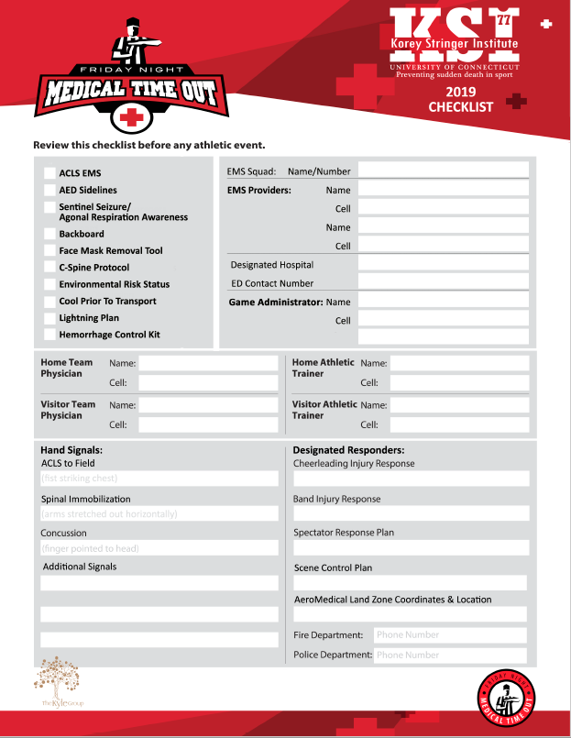
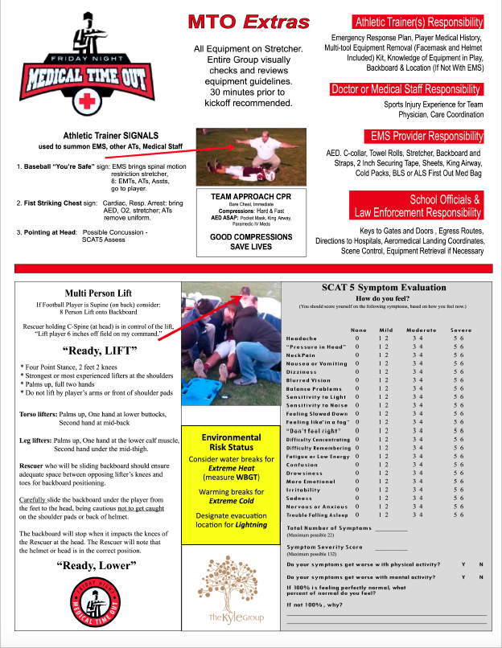
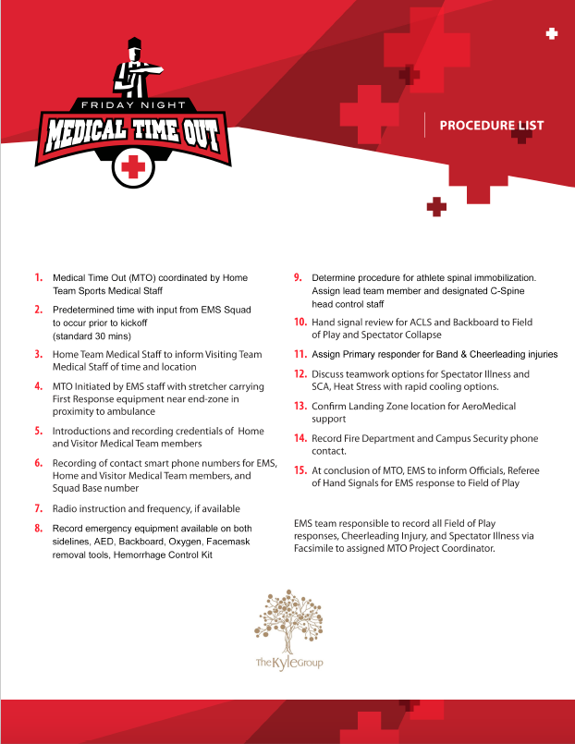
Appendix X. Roles & Responsibilities
[if not within the venue-specific EAP, ensure this has been discussed and documented per venue/team as necessary. If using the venue-specific template provided in this EAP Template, this is not necessary and can be deleted]
- [insert who] will provide primary medical care to the patient.
- [insert who] will call for emergency services.
- [insert who] will retrieve emergency equipment.
- [insert who] will open gates.
- [insert who] will act as crowd control.
- [insert who] will meet and direct the ambulance to the site.
- [insert who] will contact stakeholders.
- [insert who] will accompany the patient to the hospital.

This is embedded within the venue-specific EAP in Appendix A above.
Venue Roles & Responsibilities (these are the primary individuals; others may assist with tasks as necessary)
1. Primary Provider of Medical Care - 5. Crowd Control -
2. Calls 911 - 6. Meets Ambulance -
3. Retrieves Emergency Equipment - 7. Contacts Stakeholders -
4. Opens Gates - 8. Accompanies Pt to Hospital –

Appendix D. Emergency Contact Tree
Emergency Situation Contact Tree

Injury or Sudden Illness
First Responder or Coach on Scene
CARE
Life-Threatening Condition
CALL
911
get the emergency equipment
Call Parent/Guardian
Call Athletic Trainer
Call Athletic Director
(if warranted)
Call
Athletic
Trainer
Provide care until EMS arrives.
Do not leave victim.
Provide proper first aid and care until athletic trainer arrives.
Do not leave victim.
CARE
CARE
CARE
Non-Life-Threatening Condition
CHECK

Appendix E. Emergency Contact Numbers

Off Campus Contacts | Phone Number
Emergency | 9-1-1
Police department
Fire and Ambulance
[Nearest] Hospital
[Second Nearest] Hospital
Hazardous Materials
Poison Control Center

On Campus Contacts | Phone Number
Athletic Training Clinic
Athletic Trainer
Athletic Director
Administrative Office
School Counselor Office
Nurse
[additional personnel as organization requires]
[additional personnel as organization requires]

Appendix F. Emergency Equipment Location

[delete equipment the organization does not have access to]

EQUIPMENT | LOCATION(S)
AED
Spine Board
Splint Bag/Crutches
Emergency Medical Kit
Medical Trunks
Rectal Thermometer
Cold-water immersion tub
Airway Management
Albuterol
Epipen
Glucometer
Equipment removal tools
Pulse oximeter
Blood pressure Cuff
Stethoscope
Supplemental oxygen
Biohazard Materials
Ice
Golf Cart
Nearest landline

Appendix G. Maintenance of Emergency Equipment

Date | Emergency Equipment | Status | Name of Individual Who Checked the Equipment | Notes

Appendix H. After-Action Debriefing

Date of After-Action Debriefing:
Names of Individuals at Debriefing:

Incident:
Date of Incident:
Times of Incident:

Please indicate the following information, and add in additional topics, that was reviewed during the after-action debriefing:

Management Coordination
- Roles & Responsibilities
- Overall Preparation, Review, Rehearsal of EAP

Communications
- Emergency signaling procedures
- Response Time

Medical Care
- Use of personal protective gear
- Care/treatment of patient
- Victim hand-off to EMS

Supply/Logistics
- Accountability
- Resource tracking
- Equipment care/maintenance
- Resupply needs

Appendix I. Documentation of Review and Rehearsal of EAP, Sign-In Sheet

Topic: EAP Review and Rehearsal
Sign in Sheet

This is an example for organizations to utilize for an attendance sheet. Revise or delete as you wish.
Individual Name (printed) | Sport | Signature
Notes:

Appendix I. Documentation of Review and Rehearsal, Sign-Off Form

*The below form is an example form for individuals to fill out during the EAP Review and Rehearsal meeting. Revise this form as you see fit for your organization, have each individual fill out the form and store this form with the Attendance log from the previous page. Delete this statement prior to use.

I _____________________________________________________________ (print stakeholder name) serve as the ______________________________________________ (role) and have read and understand the Emergency Action Plan for [Organization Name] Athletics. I understand my roles and responsibility should an emergency occur in my presence. I have also rehearsed this Emergency Action Plan and understand my role in an emergency situation with an AT present and without. I have been given the opportunity to ask all questions and have received the proper answers to my questions.

[if applicable] I also understand that I must keep my CPR/AED and First Aid Certifications up to date and that it is my responsibility to ensure a lapse does not occur. I am also aware that I must be trained in concussion management, and it is my responsibility to ensure a lapse does not occur.

Stakeholder Name (print): _________________________________________
Role: _________________________
Signature: _________________________________________________
Date: _________________________
This document is provided by the Korey Stringer Institute, an organization housed at the University of Connecticut, as a template to assist with preliminary drafting of the above policy. Using this document and any other information (text, graphics, images or other materials) from the Korey Stringer Institute is solely at your own risk. The policies described represent best practices as interpreted by the Korey Stringer Institute at the time of drafting this document. While the Korey Stringer Institute does its best to reflect current best practices, the most appropriate policies and procedures are subject to change at and may not be directly reflected in this document. Use of this document does not constitute endorsement by the Korey Stringer Institute. Modification of the policy or procedures in this document may not reflect best practices. All policy decisions should be reviewed by appropriate local administration prior to implementation. Any individual or organization utilizing this document should use discretion and consider the individual circumstances at their work setting.

This Template has been modified from the Board of Certification, Inc. (BOC) Guiding Principles for AT Policy and Procedure Development.

