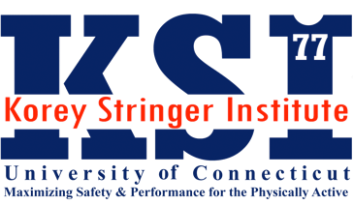
Korey Stringer Institute Summer Fellowship Program

The Korey Stringer Institute seeks talented undergraduate and graduate athletic training students to apply for an 8-week research and advocacy fellowship. This fellowship will be hosted at the University of Connecticut in Storrs, CT.
This fellowship program is devoted to providing students exposure to high-level research, advocacy and education initiatives. Individuals will be provided full immersion into the daily operations of an active research lab; assisting with field studies, epidemiological investigations and laboratory protocols. Fellows will also assist KSI with advocacy initiatives and educational efforts focused on preventing sudden death in sport and physical activity at the local, state and national level.
Candidates will be selected based on the strength of their application and desire to pursue a career field related to preventing sudden death in sport and the physically active. Successful candidates will demonstrate academic excellence, quality recommendations and strong communication skills.

Number of Fellowships: 1 Fellow will be selected for Summer 2023

Fellowship Amount: Up to a $4000.00 stipend paid on a bi-weekly basis directly to the fellow

Fellowship Term: 8-weeks beginning in June 2023

Fellowship Housing: If selected, Fellow is responsible for acquiring housing for the 8-week period

Application Deadline: March 8, 2023, at 11:59pm EST.

Eligibility:
- Undergraduate junior/senior level athletic training students currently enrolled in a CAATE-accredited program
- Graduate-level athletic training students currently enrolled in a CAATE-accredited program
- Certified athletic trainers currently enrolled in graduate school
- U.S. Citizenship OR appropriate work visa

Required Materials:
- Complete Fellowship Application found on https://ksi.uconn.edu/services/education/
- Cover Letter
- Resume (Including research, advocacy efforts/interests, and/or clinical experiences)
- 3 letters of recommendation.
- Transcript verifying eligibility. May be an unofficial transcript.

Please send all completed applications to:
Aleksis Grace, MS, LAT, ATC
Associate Director of Sport Safety, Korey Stringer Institute
Email: aleksis.monsees@uconn.edu

For any additional questions, please email Aleksis Grace (contact information above)

All application materials are due by March 8, 2023, at 11:59pm, EST.

